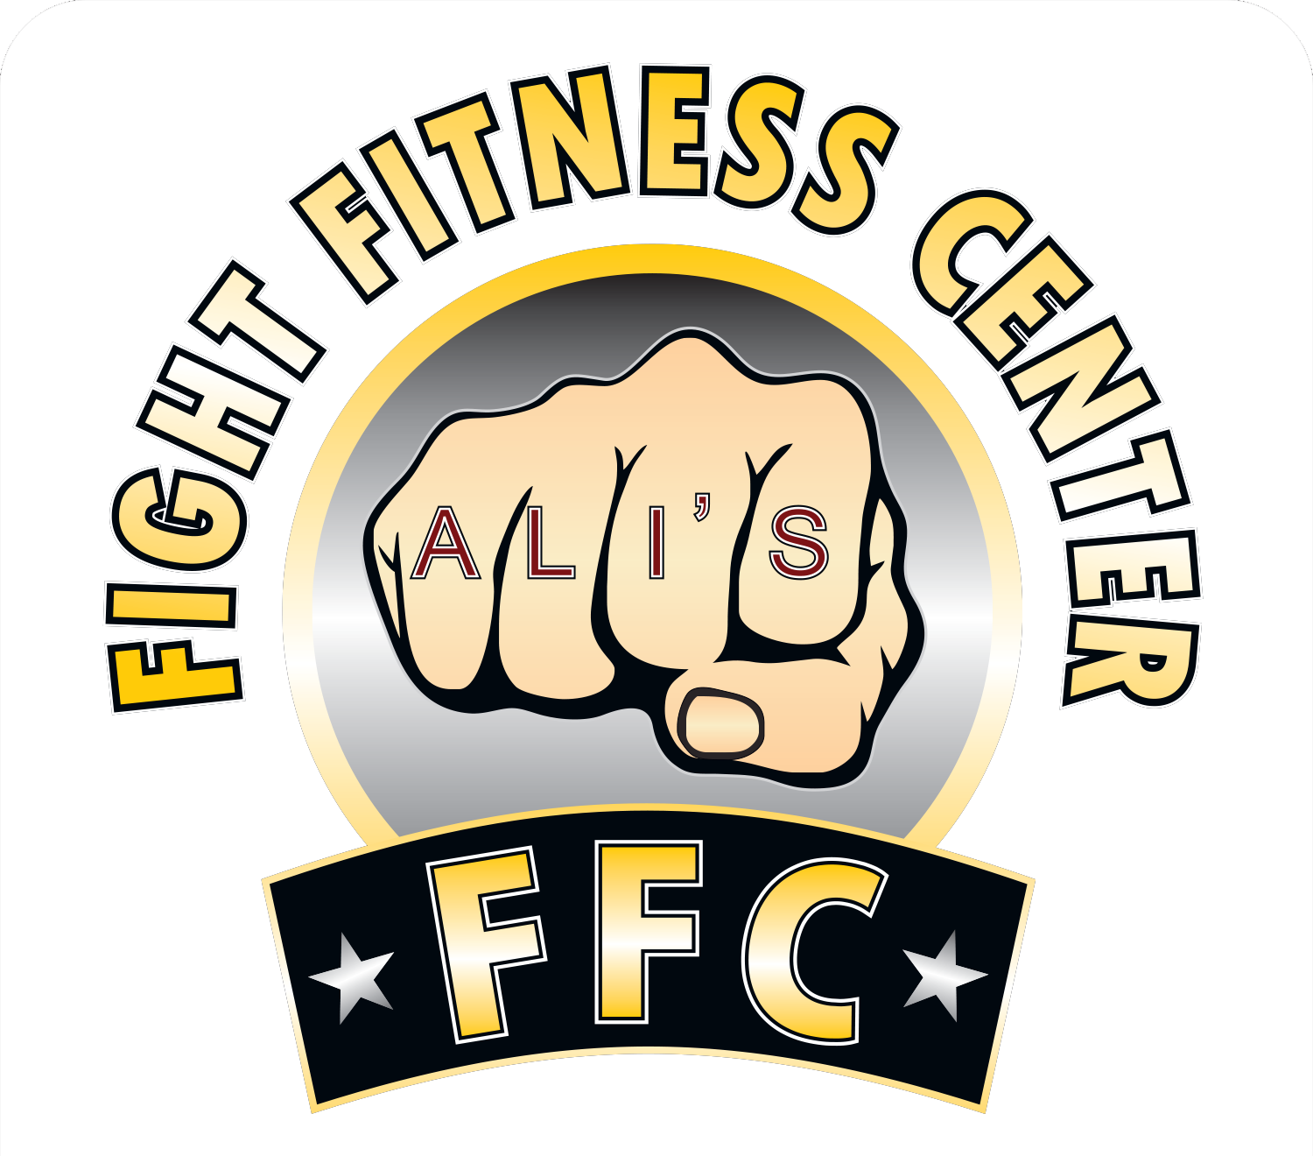
Schedule & Program Prices
1: Kickboxing & Muay Thai
Striking: Monday/Wednesday Sparring: Friday
$150 Per Month | 3 Days Per Week
Mondays & Wednesdays 6:10pm to 7:40pm | Fridays 6:10pm to 7:40pm
What we do: Practical techniques to learn the sport of kickboxing while you get in shape!
We start with an injury preventing stretch & warm up followed by Strength & Conditioning.
We progress into technique or fight drills with kicks, punches, knees, and elbows on pads, focus mitts and heavy bags.
Who can take these classes? Competitive Fighters or anyone who wants to lose weight or get in shape! All techniques learned can be used as self defense.

2: Boxing | Tuesday/Thursday/Saturday
$150 Per Month | 3 Days Per Week | Mornings or Evenings
Tuesdays & Thursdays 10am to 11:30am | Saturdays 10am to 12pm
Tuesdays & Thursdays Evenings 6:10pm to 7:40pm
What we do: Practical Techniques to learn the sport of boxing while you get in shape!
We start with an injury preventing stretch & warm up followed by Strength & Conditioning.
We progress into technique or fight drills with boxing fight strategies included.
Who can take these classes? Competitive Fighters or anyone who wants to lose weight or get in shape! All techniques learned can be used as self defense.

3: Performance Strength & Conditioning | HIIT
$150 Per Month | 3 Days Per Week
Mondays, Wednesdays, & Fridays 10am to 11:30am
Tuesdays & Thursdays 5pm to 6pm | Saturdays 10am to 11am
We combine HIIT (High Intensity Interval Training) with the Olympic lifts and sport specific strength and conditioning you will need for a balanced fighter’s body. This class is for anyone, but also benefits boxers and kickboxers with the specific strengthening and cardio conditioning drills we do.

4: Kids MMA (Kickboxing, Muay Thai, and Boxing) | Monday/Wednesday/Friday
$150 A Month | 3 Days Per Week | 10-14 Years | 1 Hour Class
Mondays, Wednesdays, & Fridays | 5pm to 6pm
Our kids classes have it all: Injury-prevention stretching, cardio, strength training, along with the same practical kickboxing and boxing techniques adults learn. Learning good sportsmanship and respect is important to us along with having fun!

